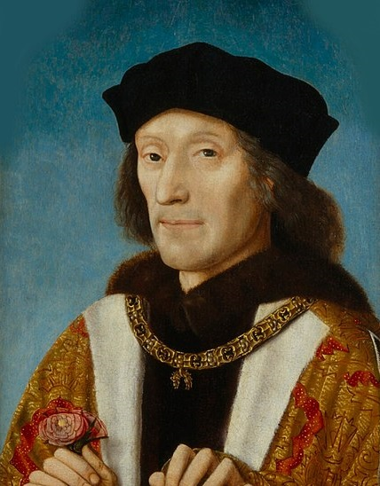
The Reign of Henry VII 1485-1509

An investigation of primary source materials relating to the reign of the first Tudor monarch

Student Booklet

Bosworth, 1485
Henry Tudor, the earl of Richmond, invaded through Wales and fought against the armies of the Yorkist king Richard III at Bosworth field. According to legend, after Richard was killed following a brave charge at Henry, the crown was found lying in a bush, from where it was taken and placed on Henry’s head by the rebel noble, lord Stanley.
Henry VII then proceeded to backdate his reign in Parliament to the day prior to the battle. He also hired an Italian academic named Polydore Vergil to write the history of England.

Henry’s reign was framed by the fact that his claim to the throne had been weak but writers such as Vergil were hired to establish its strength.
Henry had to face 3 rebellions from supporters of the previous ruling dynasty. On two occasions these rebellions were based around pretenders to the throne wishing to replace him. Henry was also forced to deal with 2 tax rebellions at either end of the country in addition to the ruling of a growing country.

The key question for us to investigate:

How important was money to securing the reign of Henry VII 1485-1509?

Royal Finances in Early Modern England: Essential background information

- Sound finances were an essential aspect of a stable monarchy. In an era when the personality of the monarch played a significant part in royal power, a poor handling of royal finances had already contributed to the removal of two kings, Richard II (1399) and Henry VI (1461).

- Finances can be separated into income and expenditure. In terms of income, monarchs were wealthy landowners and could gain revenue from this, in addition they were often granted customs duties and the profits of justice (court fines).

- Expenditure fell into either the routine or exceptional. Routine expenditure would normally include such elements as defending the borders with Scotland and Wales and maintaining law and order. Exceptional spending could involve ceremonial expenses including weddings, significant additions to the royal household budget and alliances with other countries. If the monarch wanted to go to war, taxes had to be approved by Parliament and would normally be granted. By 1485, these would involve a negotiation in which Parliament would seek something in return for the grants.

- As the collection of taxes was often slow and inefficient in places, the Yorkist Edward IV (1461-1483) changed the running of royal finances and controlled both the collection and spending of monies from the private royal chambers in a method labelled Chamber Finance. This method would be continued under the Tudor monarchs.

What points can we add about Henry VII?

Historians on Henry VII: How important was money to securing the throne?

For each view - read the extract carefully, summarise the overall view of Henry in your own words, outline how important money was to the king and use the final column to select at least one quotation that you can use both in these lessons and in your essays on Henry.

Historian | Overall View on Henry VII | How important was money? | Key quotation(s)
John Guy (1988)
Caroline Rogers (1991)
Alexander Grant (1985)
Sean Cunningham (2005)
Ian Dawson (1995)

How to Search the Database

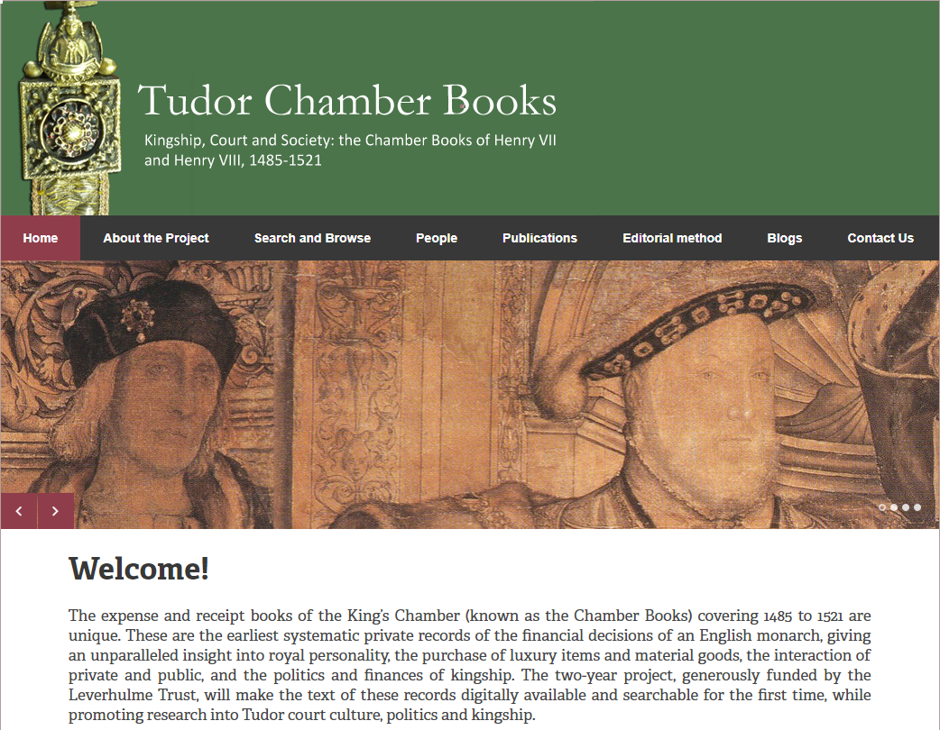
On the main page - select Search and Browse and then click the link to the development site.

Then enter your keyword into the search box - you can alter the date range for your search and chose either original or modernised spelling.
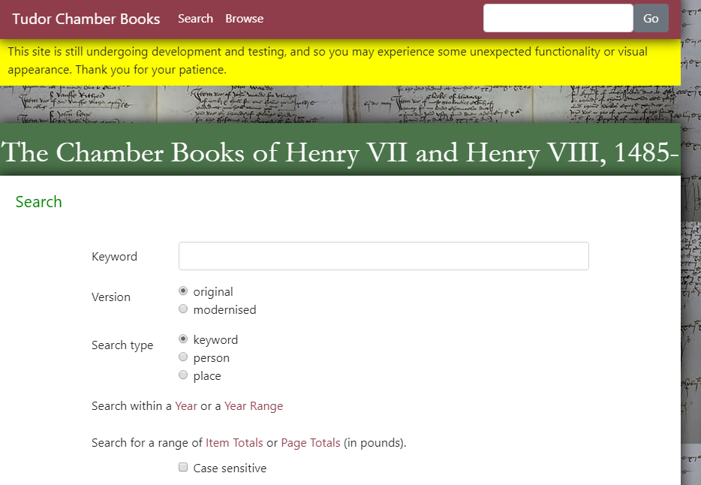

Once your keyword is entered into the database your search results will be displayed as shown in the example over the page for the keyword ‘Wales’.

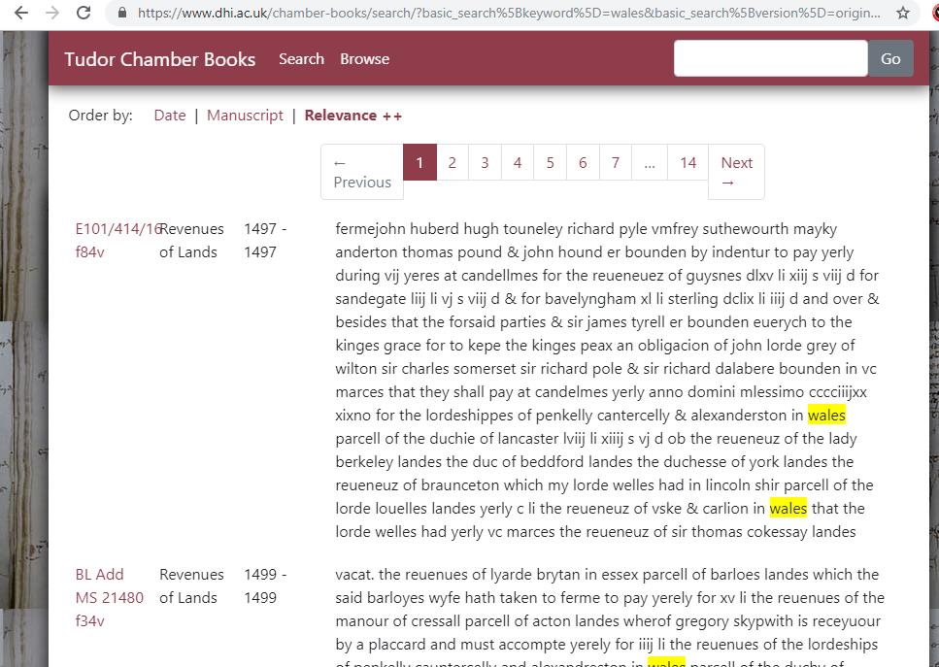

All relevant responses will appear with the keyword highlighted. The database will also indicate which institution holds the document (BL = British Library), the manuscript number and the folio (volume) reference as well as the years each specific document relates to.

The manuscripts use Roman numerals to show figures in pounds, shillings (s) and pence (d). Some of these are as follows:

I = 1, IV = 4, V = 5, IX = 9, X = 10, XX = 20, XL = 40, L = 50, LX = 60, C = 100, D = 500,
M = 1000

When using lowercase numerals, the writer will often use a j rather than an i for the last number, so a figure that reads xviij = 18

Searching the Chamber Books database activity
(https://www.tudorchamberbooks.org)

Search item | Notes (2-3 points of interest) | Amounts noted
Loss
Dice
Tens
Greyhounds

Enquiry 1: Student guidance sheet: Henry’s Spending
Was Henry avaricious? What can we learn about Henry from his spending?

In your group, remind yourselves of the points made by historians regarding Henry’s spending. What did they say about it? In your investigation you are going to use evidence from the Chamber books to see if it confirms or challenges those views.

Investigation 1: Team work on payments 1495-8
- As a team, go to the Chamber books database ( https://www.tudorchamberbooks.org) and the search function.
- Click on ‘Year Range’ and set this to 1495-98.
- Type in ‘Payments’ as your search word.
- Click on ‘Go’. This will result in 3 lists of payments made by the king in these years.
- Click on the red manuscript reference on the left side eg BL Add MS 7099 f39
- Then click on ‘Modern Spellings’ at the top.
- You will then have a list of payments. Although it has mostly been rewritten in modern English, some items may still be hard to understand and the spelling and grammar will be different. However, there still will be many items you can understand.
- Open up the ‘RECORDING GRID FOR HENRY VII’S SPENDING’ document.
- You need to categorise the kinds of items the king is spending money on. The first category- jewels and plate- is done for you. You can record a few examples in this part of the grid.
- Now agree what other categories might work well and write these in the left hand column. Record items from the payments list you have read.

Investigation 2: Individual or paired research 1499-1509
- Divide your team up according to years eg 14-99-1502, 1503-6, 1507-9.
- Using the Year Range’ function and the ‘Payments’ search word, find at least 3 more documents recording royal payments.
- Record items you have found precisely on the grid.

Investigation 3: Plenary
- Reunite as a team and review the grid evidence.
- Using the money guide sheet, estimate the relative amounts of money the king has spent on different items.
- Now, as a team, fill in the ‘Review of Findings’ page.

A simple guide to Tudor money

General points
It is important to understand that the Tudor system of money was very different from ours. For one thing, we have a decimal system ie £1=100 pence but in Tudor times they used a system of pounds, shillings and pence where £1 = 240 pence.

Another key difference is that in Tudor times many people paid bills in goods. As you can see in the accounts the king was quite often paid in wool. Bartering (exchanging) goods was also very common. Furthermore many labourers ‘lived in’ ie they had free board and lodging as part of their job.

The value of money was very different in those days and although there are converter systems online these should be treated with some caution. There was rapid inflation between 1500 and 1540 so prices and wages in 1500 were often a lot of lower than in 1530 although living standards might not necessarily have been poorer.

Prices for goods also need to be treated with caution. This was a rural, agricultural society so most people made their own bread rather than buying a loaf and brewed their own beer too. Costs varied due to all sorts of reasons, including how good the harvest was in that year.

Guidance on income and wages at this time:
Henry VII’ s income was around £100 000 per year.
The 3rd Duke of Buckingham, a leading nobleman, had an income of around £5000.
A carpenter earned around 40 pennies per week or between £8-£9 per year.
The average servant’s yearly wage was around £4.

Some common units of money:
one sovereign = one pound
one pound = twenty shillings
one mark = two thirds of a pound (13 shillings and 4 pence, 3000 marks -£20000).
one crown = five shillings
one half-crown = two shillings and six pence
one shilling = twelve pennies
one sixpence = six pennies
one groat = four pennies.
This is the most reliable currency converter: http://www.nationalarchives.gov.uk/currency-converter/#

Recording Grid for Henry VII’s Spending
CATEGORY | DATE | AMOUNT | DETAILS
Jewels and plate
(plate = cups, plates and ornaments made out of precious metals such as gold and silver)
Category 2
Category 3
Category 4
Category 5
Review of Findings
What did Henry spend most of his money on?

Did his spending change over time?

How does your research confirm or challenge the comments of historians?

Enquiry 2: Student guidance sheet: Henry and the nobles

What does an investigation into wardships tell us about Henry’s relationship with the nobles?

In your group, remind yourselves of the points made by historians regarding Henry’s relationship with the nobles. What did they say about it? In your investigation you are going to use the evidence in the Chamber books to see whether Henry’s use of wardships confirms or challenges those views.

Investigation 1: The use of wardships by the king- Trussell as a case study
- Read the information sheet on feudal dues and wardships carefully.
- Go to the chamber books database: https://www.tudorchamberbooks.org/
- Type in ‘Elizabeth Trussell’ into the database and click on go.
- Click on the top item, E36/214 f228v
- Then click on ‘Modern Spellings’ at the top.
- Read the second two items on the list. They are about the wardship of a heiress called Elizabeth Trussell. Between you, try and work out what they are about.
- Now read this article about Elizabeth Trussell https://www.tudorchamberbooks.org/the-trussell-wardship/ which is based on the chamber books’ evidence. Fill in relevant points on the recording grid document using this information. Does this case overall suggest the king is unfair in his use of this feudal right?

Investigation 2: The use of wardships by Henry VII
- Read the information sheet and add any factual points you can to the recording grid.
- Divide into teams to investigate different examples:
- Team 1- You will study the the wardships of the mentally incapacitated. Use the search terms ‘idiot’, ‘idiocy’ and ‘Montague’ to find examples. Look to see any evidence that the family are caring for the idiot and how much money is involved.
- Teams 2 and 3 - You will study the different ways wardships brought in money for the king. Divide into two teams - one to investigate the period 1485-1502, before the appointment of a Master of the Wards and one after. Remember you can use the ‘Year Range’ function to focus your research.
- Type in ‘Ward’ as the search term. Find examples of the different ways the king acquired money from wardships. Record any notable examples eg where there seemed to be a lot of money being gained or evidence of dispute.

Investigation 3: Plenary
- Reunite as a team and review the grid evidence.
- Record you main judgements in the ‘Review of Findings’ page.

Recording Grid for Henry VII’s Use of Wardships
EXAMPLE OF WARDSHIP | Evidence that Henry was money grasping, unfair or punitive | Evidence that Henry was reasonable and fair in his use of this wardship
Elizabeth Trussell

Points from the information sheet on feudal dues
Points from study of mentally incapacitated.

Points from the period 1485-1502
Points from the period 1503-9

Review of Findings
Your main evidence that Henry was mean, grasping or unreasonable

Your main evidence that he was not particularly unreasonable

How does your research confirm or challenge the comments of historians you studied in lesson 1?

Enquiry 2: Information sheet on feudal dues and wardships

The king was head of the feudal system. This meant that his main nobles, or tenants in chief, held their land from the king. When they died, in theory at least, he could claim it back. Although this did not generally happen, the king was entitled to payments or feudal dues and had certain powers he could exercise, as recognition of his rights, such as:

- when a nobleman died and his son and daughter(s) inherited his land they had to pay feudal dues to the king
- when a nobleman’s widow wished to remarry she had to seek the king’s permission and if she wished to marry someone he did not choose, to buy a licence.
- payments were made to the king when lands were transferred from one landowner to another.

The king also had rights of wardships. This meant he could control the lands and revenues of heirs who inherited their lands before the age of 21 or heirs who were judged to be mentally incapacitated. Sometimes there was only a short interval before the heir could take over their lands but, in numerous cases, the king was able to benefit from substantial revenues from wardships like these for many years.

Often the king allowed a nobleman to take over the wardship for a fee. In the case of the mentally incapacitated (they called them ‘idiots’ in Tudor times) often the family would care for them in return for payment to the king.

Henry VII took his control of wardships very seriously and exploited opportunities to sell wardships or drive a hard bargain over the marriages of wards. In 1503 he appointed Sir John Hussey to be Master of the King’s Wards; responsible for managing them. His revenue from wardships increased substantially during his reign. In 1487 his income from wardships was around £350 but by 1507 he was earning around £6000 a year from this source. According to Gunn, by 1504-6 wardship and livery alone were raising nearly a tenth of royal income.

This does not necessarily mean that Henry was abusing his rights as a feudal overlord but there is some evidence to say he was more efficient and harsher than his predecessors. Sir George Tailboys had to pay £500 to the king to have himself not declared a lunatic and his lands taken into wardship and the powerful Duke of Buckingham had to pay £2000 when his mother remarried without royal permission. Historians have certainly claimed that Henry abused his powers: ‘Henry VII was accused of abuse of powers arising from the livery of lands and temporalities, disputed inheritances, the marriage and ravishing of wards and widows, negligence and corruption in office, breach of the peace, and lawsuits in various courts.’

Enquiry 3: Student guidance sheet- Henry’s security

What do the chamber books tell us about how Henry VII kept himself secure from threats at home and abroad ?
In your group, remind yourselves of the points made by historians regarding Henry’s security both at home and abroad. What did they say about it? In your investigation you are going to use the evidence in the Chamber books to see whether Henry’s interactions with nobles and foreign rulers confirms or challenges those views.

Investigation 1: Case study of relations with the Emperor Maximilian and Archduke Philip
- Read the timeline summary of Henry’s relations with the Holy Roman Empire
- As a team, go to the Chamber books database and the search function.
- Type in ‘Maximilian’ as your search word. Click on ‘Go’. This will bring up a ‘voucher’ for 1502.
- Read this carefully. As a team work out the main things it is saying.
- Discuss what it suggests about Henry’s relationship with Maximilian and the role money played in it.
- Now find the reference in 1505 to a payment to Archduke Philip. As a team and using your timeline sheet, work out why Henry is paying so much money to Philip in this year.
- Record key points on the grid provided.

Investigation 2: Team studies of threats and security
- Team 1- study the timeline of the career of Perkin Warbeck. Now type in ‘Perkin’ and ‘Warbeck’ into the search function and record what Henry’s accounts reveal about how he is managing the threat. Put relevant points in the recording grid.
- Team 2: read the information about Henry and his spies. Now type in ‘spy’ and ‘espie’
(old fashioned spelling) into the data base, remembering to set the date range from 1485-1509. Fill in the recording grid.
- Team 3: read the information about the port of Calais. Now type in ‘Calais’ remembering to set the date range from 1485-1509. Identify any items which are about defence, information or security. Fill in the recording grid.

Investigation 3: Plenary
- Reunite as a team and review the grid evidence.
- Record you main judgements in the ‘Review of Findings’ page.

Enquiry 3: Information extras

Timeline of relations between Henry VII and the Emperor Maximilian and Archduke Philip
1489 | Maximilian and Henry signed the Treaty of Dordrecht, agreeing to send armies to Brittany to help Henry resist an invasion from France. Maximilian failed to provide any troops to support Henry’s army.
1493 | Maximilian, who was ruler of Burgundy, was elected Holy Roman Emperor. His son, Archduke Philip became ruler of Burgundy (modern day Netherlands and Belgium) but as he was still young, Margaret of Burgundy acted as regent.
1493-6 | Margaret of Burgundy actively supported Perkin Warbeck, who claimed to be the rightful ruler of England. Henry wrote a letter to Archduke Philip protesting about Margaret’s support for Warbeck but this was ignored. There was a trade embargo between England and Burgundy as a result.
1496 | Warbeck left Burgundy, the embargo ended and a new treaty was signed.
1501 | Edmund de la Pole, a Yorkist rebel with royal blood, arrived and was welcomed at the court of Emperor Maximilian
1502 | Emperor Maximilian signed a treaty with Henry agreeing not to harbour rebels but made no attempt to arrest de la Pole.
1504 | When Isabella of Castile died, there was a bitter dispute about the succession as both Ferdinand of Aragon and Archduke Philip claimed the territory.
1506 | Archduke Philip and his wife Joanna were shipwrecked off the English coast on their way to claim the throne of Castile. Henry used the opportunity to impose the Treaty of Windsor in which they promised to hand over de la Pole in return for English support for their claim to Castile and improved trading terms.
1506 | Edmund de la Pole was handed over but Philip died shortly after.

Notes on Calais

Calais is a port on the west coast of France, only about 20 miles from England. In late medieval times England had held substantial lands in France but these were all lost in the reign of Henry VI, except for Calais and an area around it called the Pale of Calais. As it was surrounded by potentially hostile French territory, Calais had to be heavily fortified and garrisoned. It was important commercially for England, for the wool trade, especially during the embargo with Burgundy 1493-6. It was also important strategically as it could act as a base in any European war and a naval base for channel shipping.
The career of Perkin Warbeck

Date | Warbeck’s career
1491 | Warbeck appeared at Cork in Ireland and claimed to be Richard, Duke of York.
1492 | Warbeck was received as the rightful claimant to the English throne by the French King Charles VIII.
1493-6 | Warbeck was supported by Margaret of Burgundy.
1496 | Warbeck arrived in Scotland. An attempted invasion of England failed.
1497 | On his third attempt to invade England, from the south west, Warbeck was captured.
1499 | Warbeck was executed for treason.

Notes on spies and spying:

There is nothing particularly modern about governments using spies, intercepting mail and planting informers in order to improve their national security. Henry VII, whose position on the throne was always insecure and who was constantly troubled by real or pretended Yorkist threats, invested a great deal in spies. He was willing to send spies abroad, for instance, to the Scottish court and the household of Margaret of Burgundy.

When Prince Arthur died in 1502, Henry was certainly spending a great deal on spies but then, so had his predecessors:

‘ Henry was indeed spending inordinate amounts of money on bribes and intelligence. Throughout the civil wars of the fifteenth century, espionage had been a constant drain on the crown’s resources: in one year alone, Edward IV had spent over £2000 on ‘certain secret matters’ concerning his kingdom, and, as Warbeck had noted, Henry was willing to stretch his budget to an almost infinite degree, by offering ‘large sums of money’ to ‘corrupt the princes in every land and country that we have been retained with’. Already Henry’s pursuit of Suffolk (Edmund de la Pole) was involving financial transactions on a massive scale - and as it turned out this was only the beginning’.

Enquiry 3: How did Henry keep his throne secure? What role did money play in this?
Aspect | Inferences about Henry’s security
Relations with the Emperor Maximilian

Archduke Philip

Perkin Warbeck

Use of spies

Calais

Review: How did Henry keep his throne secure? What role did money play in this?
What role did money play in keeping Henry secure?

What conclusions could be drawn from the evidence about how Henry secured his throne?

Some additional source reading: The Reign of Henry VII 1485-1509

Also we wol that our executors, yf it be nat doon by our self in our life, cause to bee made an ymage of a king, representing our owen persone. The same yamge to be of tymber, covered and wrought accordingly with plate of fyne gold, in manner of an armed man; and upon the same armour, a coote armour of our armes of England and of Fraunce enameled, with a swerd and spurres accordingly. And the same ymage to knele upon a table of silver and gilte, and holding betwixt his handes the crowne which it pleased God to geve us, with the victorie of our ennemye at our first felde. The which ymage and crowne, we geve and bequethe to Almighty God, our blissed Lady Saint mary, and Saint Edward, King and Confessor; and the same ymage and crowne… be set upon, and in the myddes of, the crest of the shryne of Saint Edward… and we wol that said ymage...may clierly appere above and over said crowne;... and in the same be graven and writen with large letters, blakenameled, thies words REX HENRICUS SEPTIMUS.
Henry leaves instructions for his tomb E23/3 The National Archives

Trusty and well-beloved, we greet you well, letting you witte (know) that, as well by our spies that we have in the parts beyond the sea, as otherwise, we understand that our enemies of France prepare themselves to do all the hurt and annoyance that they can compass and devise to this our realm and subjects of the same; for the resisting and subduing of whose malicious purpose we shall, with God's grace, sufficiently provide and put us with a good multitude of our subjects in defensible readiness for the same intent, which can in no wise be done without great substance of good. Wherefore, we holding for undoubted that ye bear a singular tenderness to such things as concern the surety and universal weal and tranquillity of our said realm and subjects, desire and heartily pray you that ye will lend unto us the sum of £100 and to send it unto our Treasurer of England by some trusty servants of yours, to the intent that they may receive bills of him for contention (satisfaction) thereof again. And we faithfully promise you by these our letters that ye shall have repayment or sufficient assignment upon the half quinzame (fifteenth) payable at Martinmass (11 November) next coming, whereunto ye may verily trust, wherein you shall not only do unto us (a) thing of great and singular pleasure, but also cause us to have you therefore more specially recommended in the honour of our grace in such things as ye shall have to pursue unto us hereafter. Given under our signet at our manor of Greenwich the 26th day of April.
Letter requesting a forced loan from Sir Henry Vernon, 1492

Gunn, S.J.(1995), Early Tudor Government 1485-1558, Palgrave Macmillan, Basingstoke, p.126.
https://www.tudorchamberbooks.org
Penn, T. (2011), The Winter King: The Dawn of Tudor England, Allen Lane, London, p.88
Hicks, M, (1984), Attainder, Resumption and Coercion 1461–1529, Parliamentary History

